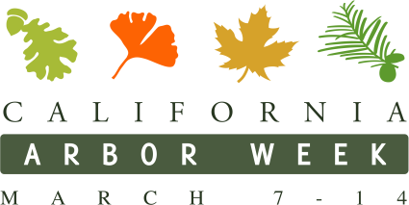
Insert Logo

California Arbor Week Proclamation
This measure would proclaim the week of March 7th – March 14th in each year as California Arbor Week and would urge [city] residents to observe the week with appropriate tree planting and tree care activities and programs.

WHEREAS, Arbor Day in celebrated nationally to encourage everyone to maintain and replenish our country’s vast forests, orchards, and woodlands; and
WHEREAS, In California, we also observe Arbor Day starting on the birthday of Luther Burbank, a famed California horticulturalist whose life’s labor produced hundreds of plants and trees that have contributed to the natural splendor and food production in our state; and
WHEREAS, California Arbor Week has the involvement of [name of organization]; and
WHEREAS, [name of organization] is improving our community by planting and caring for trees and working to improve the quality of life in [city]; and
WHEREAS, Trees are a valuable economic asset in our cities that help maintain or increase property values and attract business and new residents in urban areas; and
WHEREAS, Trees play an important role in energy conservation by modifying temperature extremes with shade and humidity, and are particularly important in reducing the amount of energy consumed in heating and cooling buildings and homes; and
WHEREAS, Trees planted in urban areas play a significant role in meeting the state’s greenhouse gas emission reduction targets by sequestering carbon as well as reducing energy consumption; and
WHEREAS, Trees directly contribute to improving California’s air quality by reducing air pollution by removing airborne particulates from the atmosphere and helping to purify the air; and
WHEREAS, Trees play a significant role in protecting and purifying California’s limited water resources by reducing surface runoff, contributing to stormwater management activity and protect urban water resources; and
WHEREAS, Trees provide essential habitat for much of California’s wildlife, including many listed, threatened, and endangered species; and
WHEREAS, Trees enhance the aesthetic quality of life in urban communities by providing a natural buffer for surface noise and natural recreational resource for California’s children and youth;
WHEREAS, Trees play a vital role in improving public health in our communities;

Therefore, I [insert name of Mayor], Mayor of [insert name of city], on behalf of the City Council, do herby proclaim March 7 through March 14 of each year as California Arbor Week, and urge all Californians to observe and celebrate the week by planting trees for our own benefit and for the benefit of future generations.

In testimony thereof, I have hereunto set my hand and caused to be affixed the city seal of [City] on this [date].

_____________________________________
Mayor

